# HT Assignment – 3 (Meghanath P.)

## Task – 1: Database Design

1. Create the database named “HMBank”

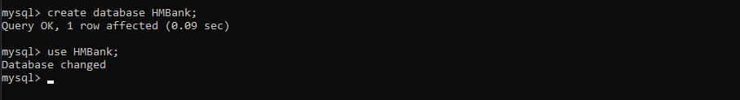

1. Define the schema for the Customers, Accounts, and Transactions tables based on the provided schema

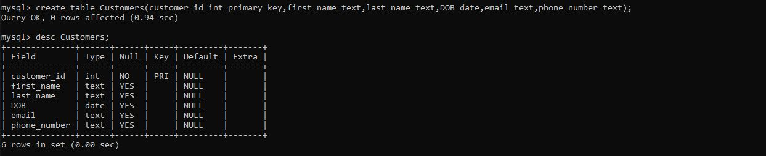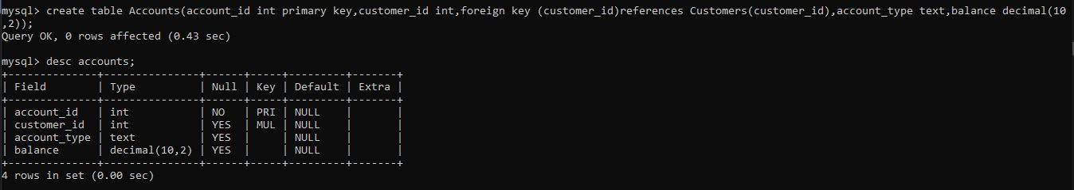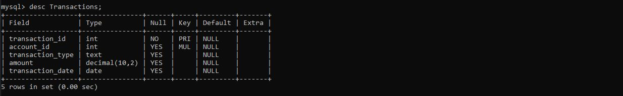

1. NIL
2. Create an ER diagram for the database

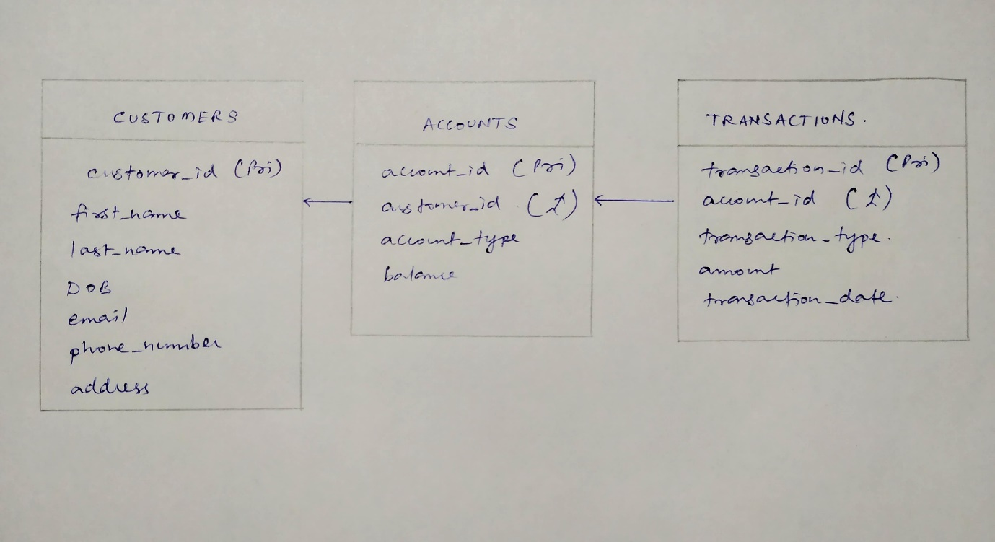

1. Create appropriate Primary key and Foreign key constraints for referential integrity

**(Already defined in schema)**

1. Write SQL scripts to create the mentioned tables with appropriate data types, constraints, and relationships

**(Already defined)**

## Task – 2: Select, Where, Between, AND, Like

1. Insert at least 10 sample records into each of the tables

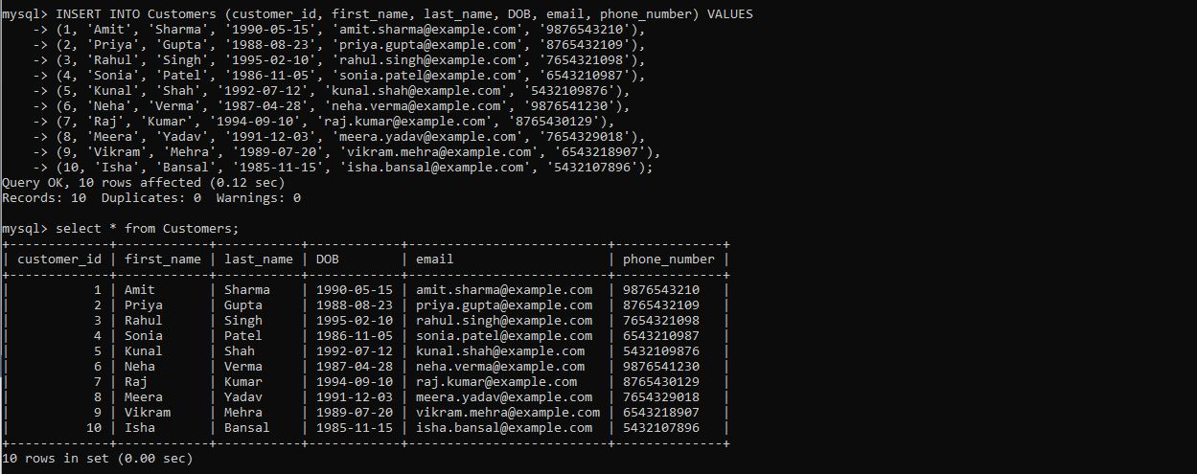

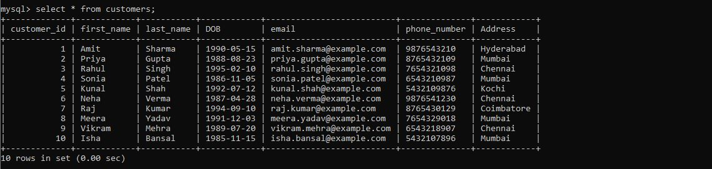

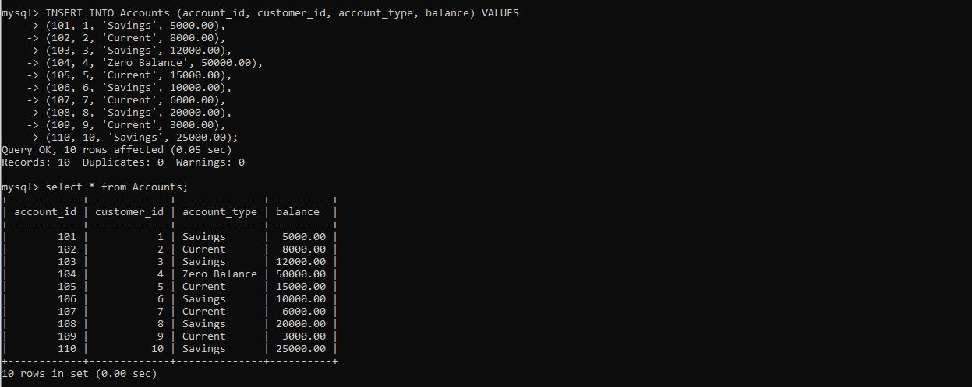

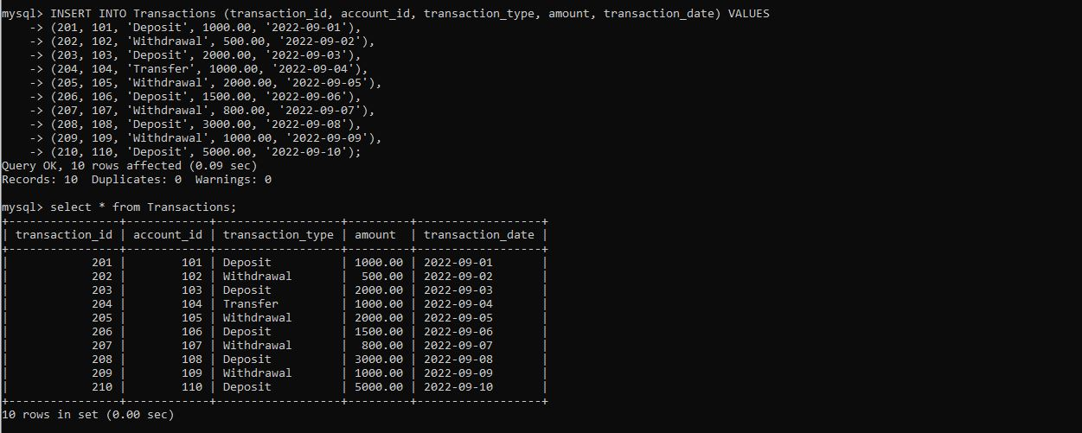

1. Write SQL queries for the following tasks:
2. To retrieve the name, account type and email of all customers

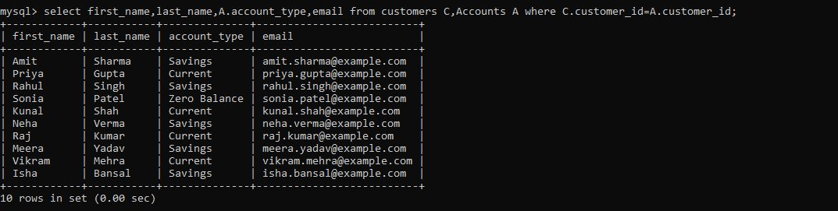

1. To list all transaction corresponding customer

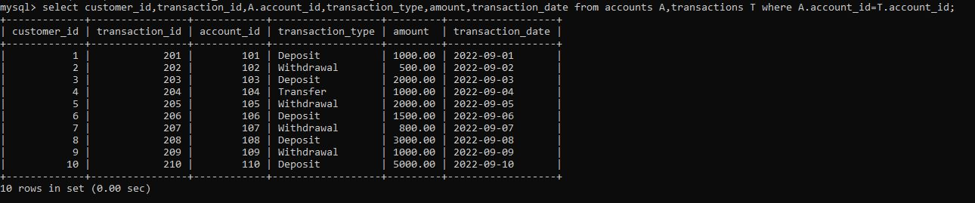

1. To increase the balance of a specific account by a certain amount

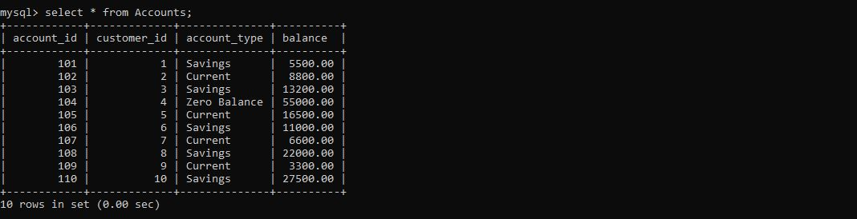

1. To combine first and last names of customers as a full_name

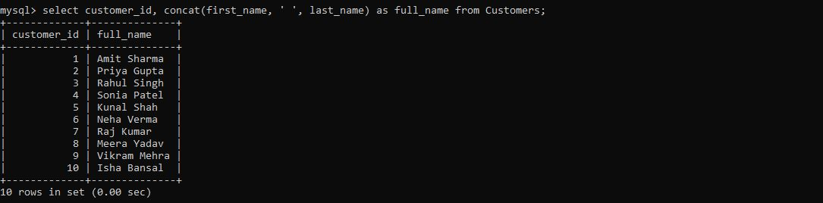

1. To remove accounts with a balance of zero where the account type is savings

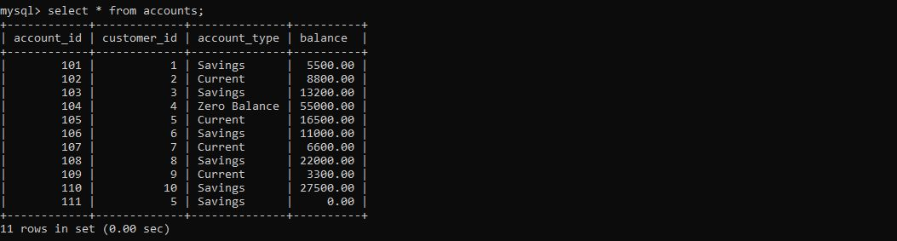

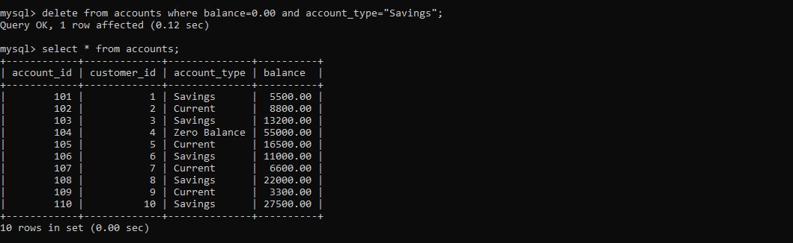

1. To find customers living in a specific city

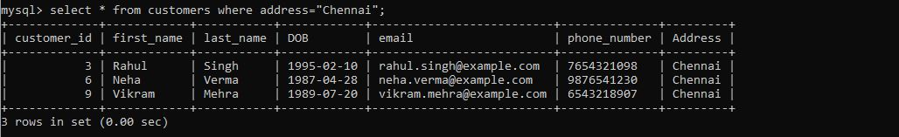

1. To get the account balance for a specific account

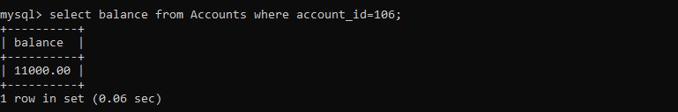

1. To list all current accounts with a balance greater than $1000

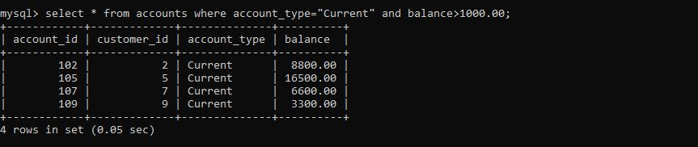

1. To retrieve all transactions for a specific account

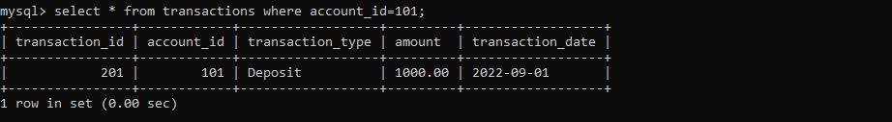

1. To calculate the interest accrued on savings accounts based on a given interest rate

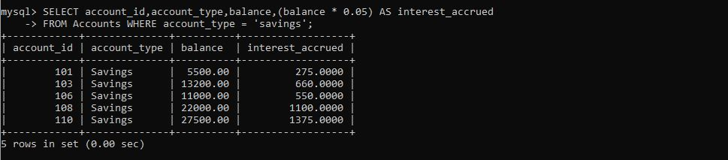

1. To identify accounts where the balance is less than a specified overdraft limit

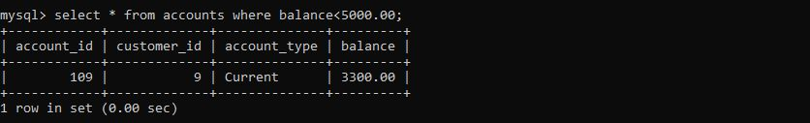

1. To find customers not living in a specific city

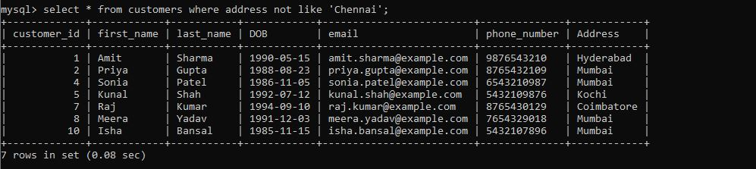

## Task – 3: Aggregate functions, Where, Having, Order By, Group By and Joins

1. Write a SQL query to find the average account balance for all customers

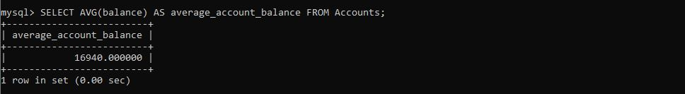

1. Write an SQL query to retrieve the top 10 highest account balances

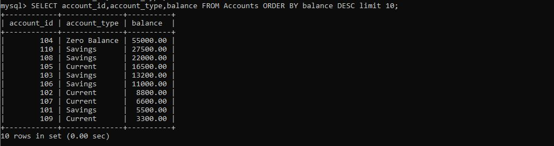

1. Write an SQL query to calculate total deposits for all customers in specific date

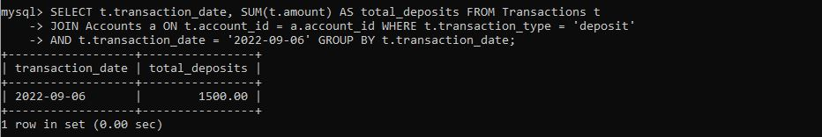

1. Write an SQL query to find the oldest and newest customers

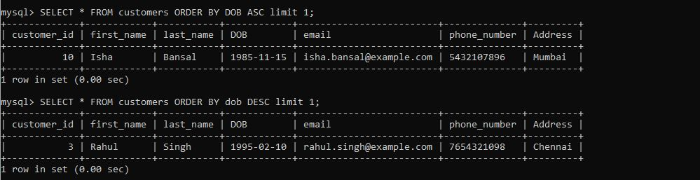

1. Write an SQL query to retrieve transaction details along with the account type

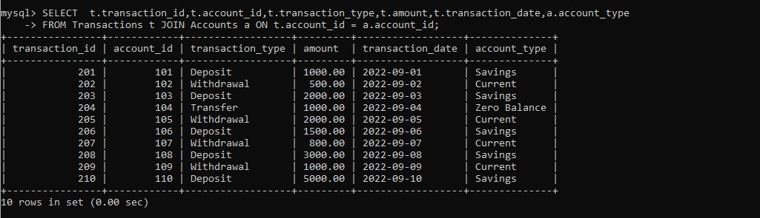

1. Write an SQL query to get a list of customers along with their account details

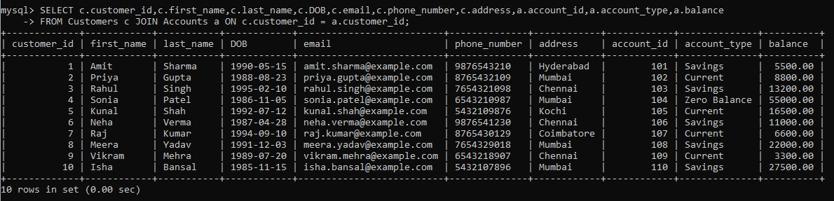

1. Write an SQL query to retrieve transaction details along with the customer information for a specific account

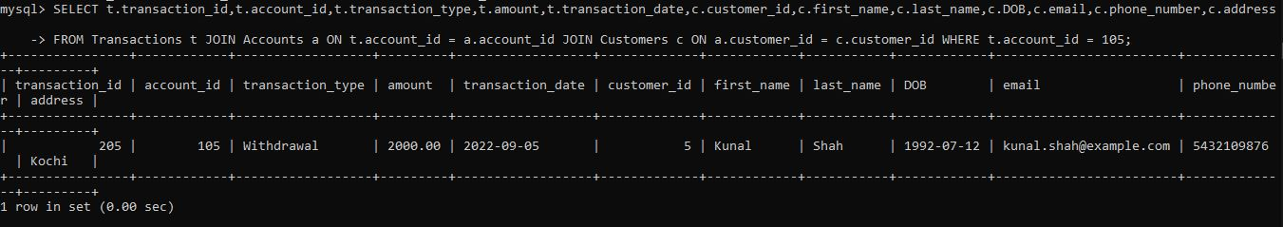

1. Write an SQL query to identify customers who have more than one account



1. Write an SQL query to calculate the difference in transaction amounts between deposits and withdrawals

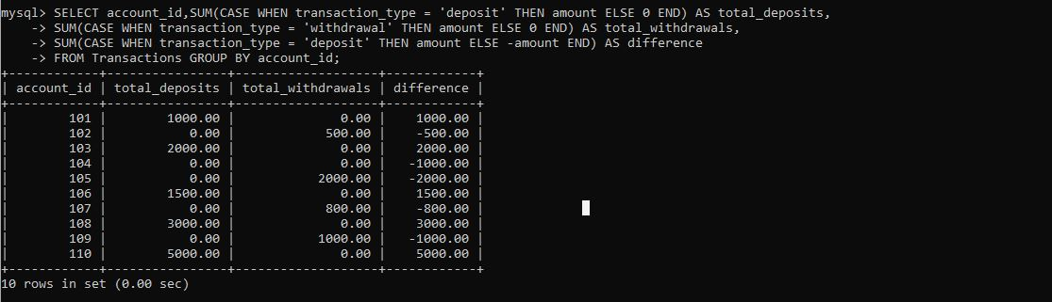

1. Write a SQL query to Calculate the average daily balance for each account over a specified period.

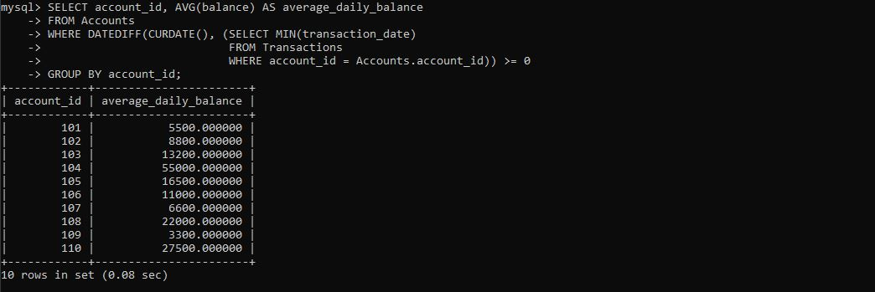

1. Calculate the total balance for each account type.

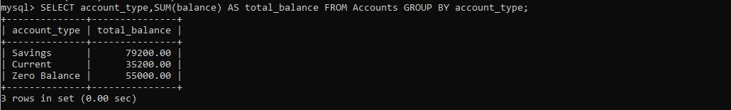

1. Identify accounts with the highest number of transactions order by descending order

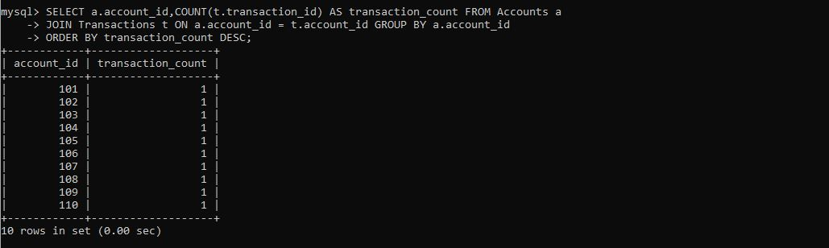

1. List customers with high aggregate account balances, along with their account types

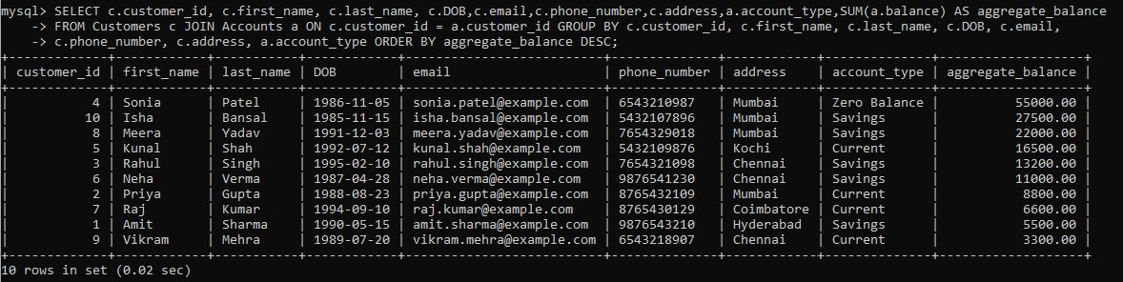

1. Identify and list duplicate transactions based on transaction amount, date and account



## Task – 4: Subquery and its type

1. Retrieve the customer(s) with the highest account balance.

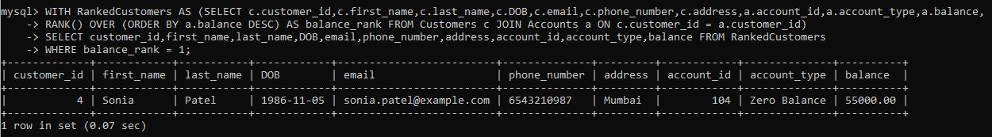

1. Calculate the average account balance for customers who have more than one account.

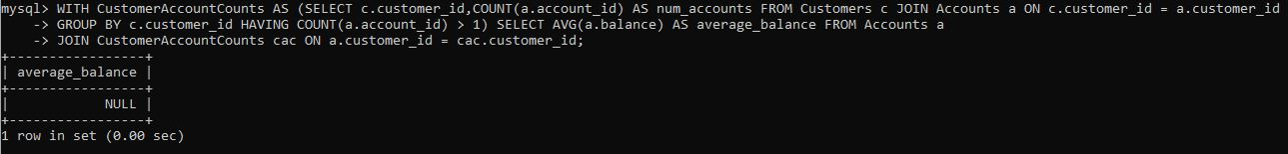

1. Retrieve accounts with transactions whose amounts exceed the average transaction amount.

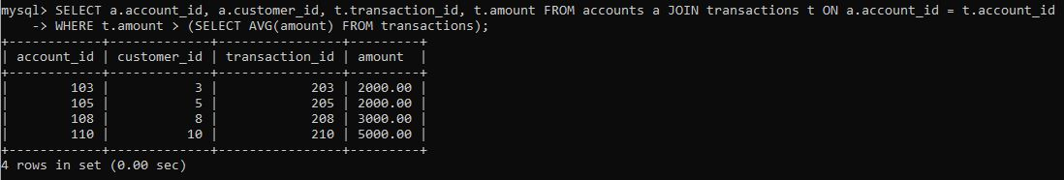

1. Identify customers who have no recorded transactions.



1. Calculate the total balance of accounts with no recorded transactions



1. Retrieve transactions for accounts with the lowest balance.

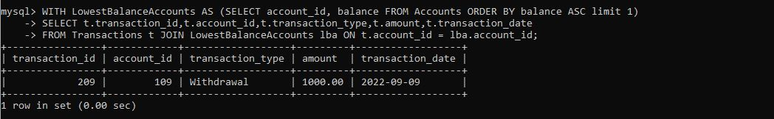

1. Identify customers who have accounts of multiple types.

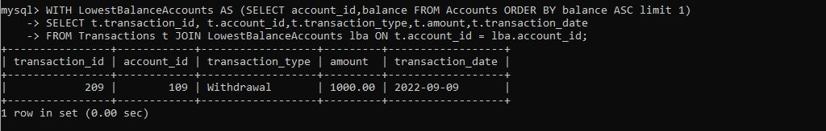

1. Calculate the percentage of each account type out of the total number of accounts.

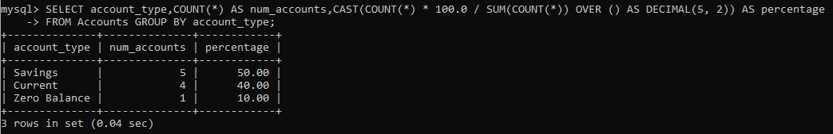

1. Retrieve all transactions for a customer with a given customer_id.

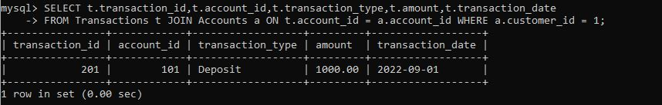

1. Calculate the total balance for each account type, including a subquery within the SELECT clause

